Dear Parent/Guardian:
Schools receive certain federal and state funding (Learning Assistance Program, teacher incentives, etc.) based on the number of children from households that are at or below the federal poverty level. This Family Income Survey provides your child’s school a way to collect household income information. This information makes sure your child’s school receives the full amount of federal and state funding and makes sure your child receives services they are entitled to when free/reduced price applications are not collected.
It is important that you complete this survey. Please complete and return this form to your school or to Mount Vernon School District Office.
Part 1. ELIGIBILITY: Figure out your total household income. Then look at the income chart below. If your income is more than your household size listed please check HOUSEHOLD DOES NOT QUALIFY.

Income Chart
Effective from July 1, 2022 through June 30, 2023
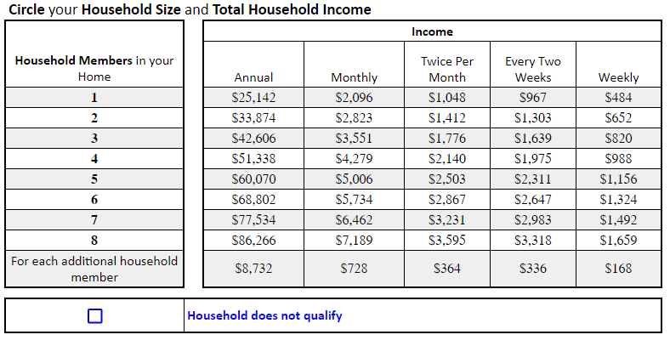

HOUSEHOLD is defined as all persons, including parents, children, grandparents, and all people related or unrelated who live in your home and share living expenses. If you’re applying for a household with a foster child, you may include the foster child in the total household size.
HOUSEHOLD INCOME is considered to be any taxable income each household member received before taxes. This includes wages, social security, pension, unemployment, welfare, child support, alimony, and any other cash income. If including a foster child as part of the household, you must also include the foster child’s personal income. Do not count foster payments as income.
Part 2. STUDENTS: Please fill in the following information for all children living with you that are attending school.
Student’s Last Name | Student’s First Name | MI | Date of Birth | School | Grade
Part 3. SIGNATURE: I certify (promise) that all information on this application is true and that all income is reported. I understand that the school will get state and federal funds based on the information I give. I understand that school officials may verify (check) this information. I understand if I purposely give false information that I may be prosecuted. I understand my child’s poverty status may be shared with other programs/agencies as allowed by law.
Signature: _____________________________ Print Name: ____________________________
Date: ________________ Phone: ________________ Email: ___________________________
Address: _______________________________ City: _____________ State: ____ Zip: ______

OSPI provides equal access to all programs and services without discrimination based on sex, race, creed, religion, color, national origin, age, honorably discharged veteran or military status, sexual orientation, gender expression, gender identity, disability, or the use of a trained dog guide or service animal by a person with a disability. Questions and complaints of alleged discrimination should be directed to the Director of the Office of Equity and Civil Rights at 360-725-6162/TTY: 360-664-3631; or P.O. Box 47200, Olympia, WA 98504-7200; or equity@k12.wa.us.
The Mount Vernon School District does not discriminate in employment, programs, or activities on the basis of age, race, color, national origin, creed, religion, sex, sexual orientation, gender expression, gender identity, honorably discharged veteran or military status, or the presence of any sensory, mental or physical disability or use of a trained guide dog or service animal by a person with a disability and provides equal access to the Boy Scouts and other designated youth groups. Inquiries regarding compliance and/or grievance procedures may be directed to the District's Title IX/Civil Rights Compliance Coordinator, Jon Ronngren, 124 E. Lawrence Street, Mount Vernon, WA 98273 (360)428-6110; Section 504/ADA Coordinator, Clint Carlton, Executive Director/Student Support Services, 920 S. Second Street, Mount Vernon, WA 98273, (360)428-6141.

